Figure 1: Conceptual diagram
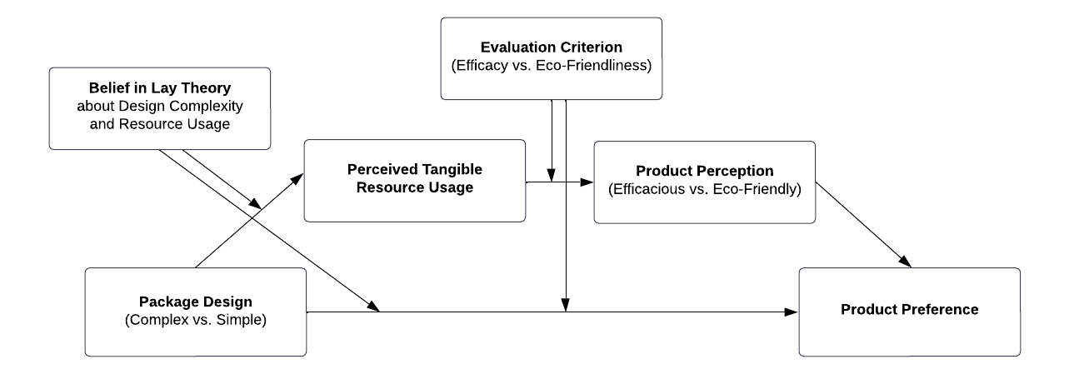

Figure 2a: Serial mediation model of efficacy perceptions (study 3a)
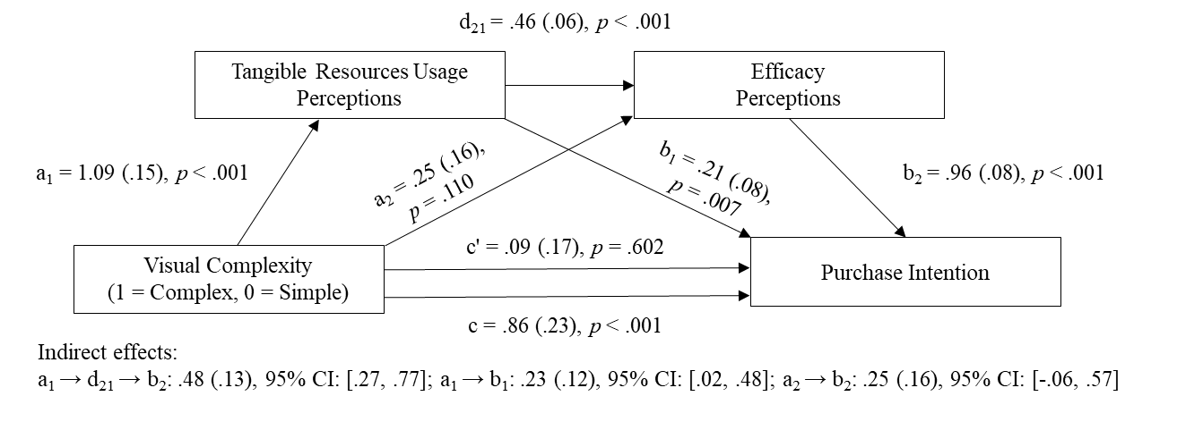

Figure 2b: Serial mediation model of eco-friendliness perceptions (study 3b)
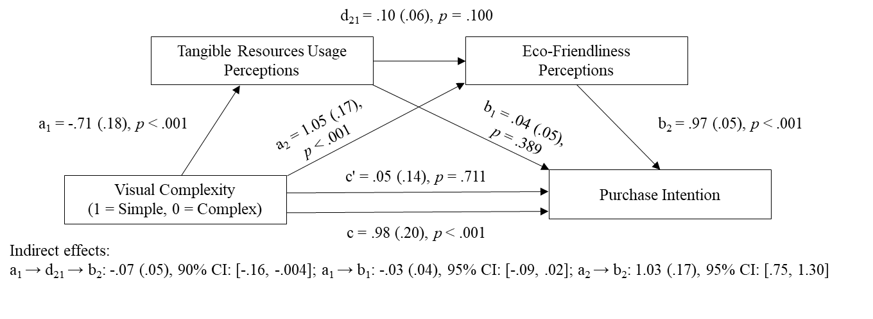

Figure 3: Johnson-Neyman analysis of belief in lay theory on efficacy perception (study 4a)

Figure 4: Johnson-Neyman analysis of belief in lay theory on eco-friendliness perception (study 4b)

